|  |  |  |
| --- | --- | --- |
| **LAB 321 Assignment** | **Type:** | **Long Assignment** |
| **Code:** | **J3.L.P0014** |
| **LOC:** | **600** |
| **Slot(s):** | **15** |

**Title:** Maria Bagnarelli's Cafe.

**Background**

### Your girlfriend: Maria want to make her cafeteria online.

Complete this assignment to help her ☺

Reference site: <http://www.simplesite.com/us-123cafe>

**Program Specifications**

Program a web site to introduce Maria cafeteria, detail functions of this website is described below

**Features:**

This website contains 3 main functions

* Function 1 : Home page : ( see PIC 01)
  + Display introduction entry and top 2 product sorted by date
  + Each product contains
    - Entry name
    - Description picture
    - Entry content
* Function 2 : About my cake ( PIC 02)
  + Print out detail price of each menu
* Function 3 : Find Maria’s cafe ( PIC 03)

You do not need to write interface for admin control panel, you can add data manually (use SQL SERVER Management studio).

Note: All data must be load from database, not hard code in page.

***Expectation of User interface:***

Pic 01 : Home Page

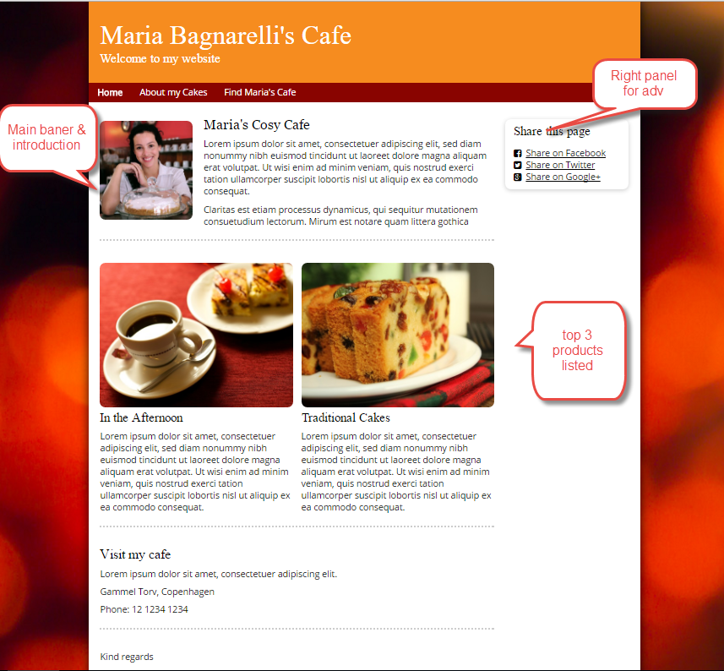

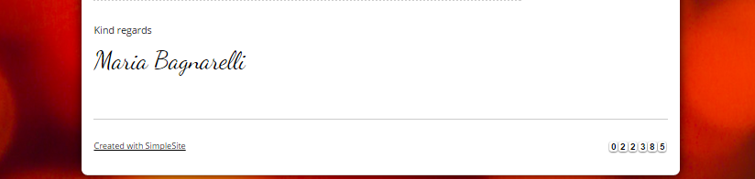

PIC 2 : About my cake

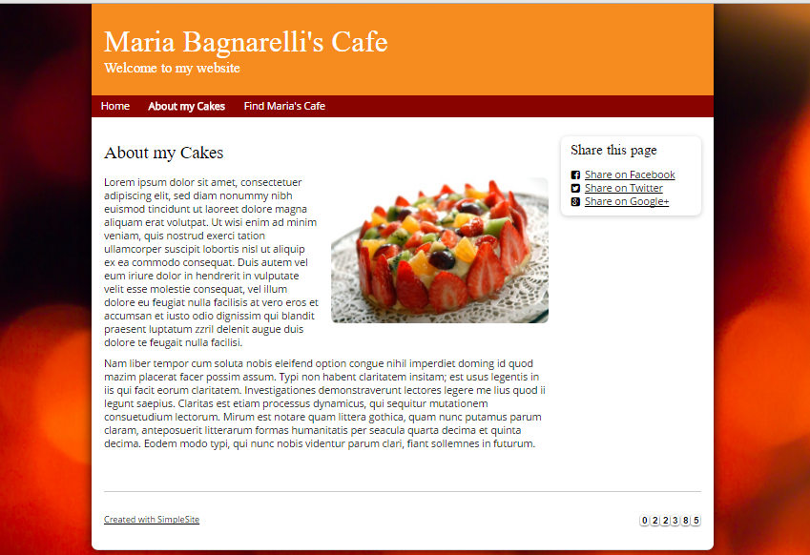

PIC 3 :

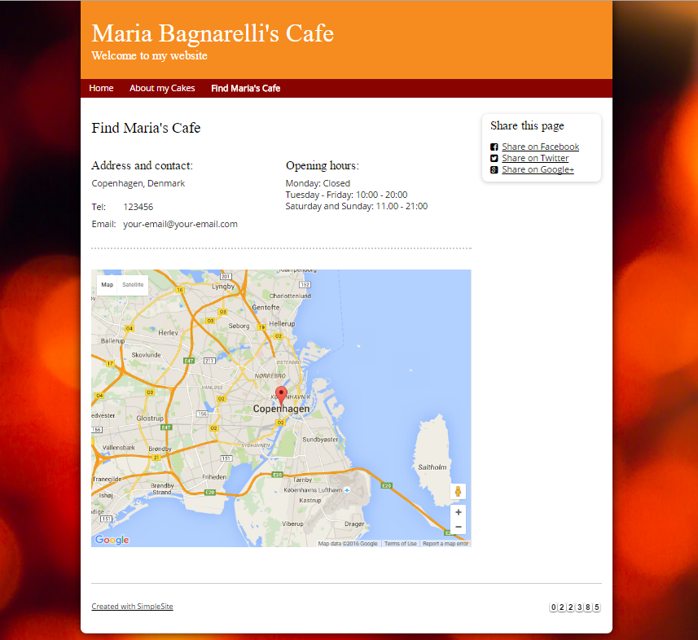

**Guidelines**

* Step 1 : Create web layout
* Step 2 : Create prototype
* Step 3 : Design database base on created prototype
* Step 4 : Code & Test